Prepared by: Danielle Brady
May 2017
creating an accesible pdf

TABLE OF CONTENTS
Create an Accessible PDF from a Microsoft Document 3
Step 1: Prepare Microsoft Document 3
Step 2: Save Microsoft Document as a PDF 3
Create an Accessible PDF from a Scanned Document 4
Paid Solutions 4
Free Solutions for PC 4
Free Solutions for Mac 5

Create an Accessible PDF from a Microsoft Document
The Office 365 Microsoft Suite of tools (Word, Excel, Power Point, etc.) have the innate ability to create an Adobe PDF WITHOUT the need to have Adobe Acrobat installed on your machine. You can tell when a PDF is accessible if you can highlight the text. An inaccessible document is essentially an image of the document and when you try to highlight the text, a box will appear about the entire document, as it would if you clicked on an image.

Step 1: Prepare Microsoft Document
With the document open you can make an edits or modifications that you need to make. If you need to have a signature on the document appear on the PDF, you can insert a saved image of the signature by following these steps:
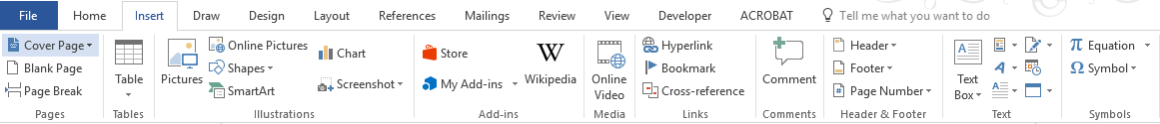
- Click on the “Insert” tab at the top of your screen
- Click on the icon in Insert Menu Bar
- Browse to where the image of the needed signature is stored
- Click on the file name and click
- Once you have the signature on the document, you can move it around as needed. To do this, left click on the image so that the icon appears.
- Click on to open the menu and select the “In Front of Text” icon that looks like this
- You can also select to ensure that where you place the signature stays near the text that you need it by even if you add to the document.

Step 2: Save Microsoft Document as a PDF
- Click on the “File” tab at the top of your screen
- Click the “Save As” link on the left side of your screen
- Select where you want to save the file by clicking on

- In the new window that has opened, name the file and change the “Save as type:” to PDF (*.pdf)
- Your saved PDF document will open and you can verify that it is accessible by trying to select text with your mouse.

Create an Accessible PDF from a Scanned Document
Written by Angela C. Wong, September 2016

Paid Solutions
There are a couple of Good software selections with good reviews for accuracy
- FineReader: https://www.abbyy.com/finereader/
- Nuance Omnipage: http://www.nuance.com/for-individuals/by-product/omnipage/index.htm
- Adobe Pro
  - Open the scanned document with Adobe Pro:
  - Choose Enhance Scans
  - Choose Enhance > Scanned Document > Click Enhance
  - Choose Recognize Text > In This File
  - Choose Settings > Output: Editable Text and Images > OK
  - Click Recognize Text
  - Save PDF file

Free Solutions for PC
The PC version of Word has an Optical character recognition (also optical character reader, OCR) OCR built into it:
- Open the scanned document in Word and it will convert the PDF into a Word document

- Click “OK” in the alert window that pops up.
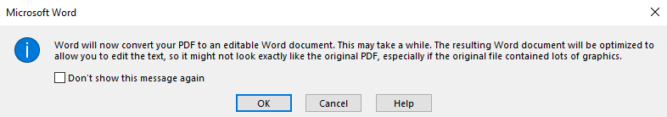
- Save your document as a Microsoft word document.
- Now that your document is editable, ensure nothing has gotten corrupted. Sometimes text, especially letterheads, are not converted properly and so you may need to modify the document to ensure text was not corrupted. Signatures are preserved as images.
- Once it has been converted into a Word document, you can then convert it back into a readable PDF document by following the instructions above on how to “Create an Accessible PDF from a Microsoft Document”

Free Solutions for Mac
The Mac version of Word does not have an OCR built into it but there is a free app for the Mac
that works like magic:

PDF OCR X Community Edition
- The software can be downloaded here:
https://itunes.apple.com/us/app/pdf-ocr-x-communityedition/id571442933?mt=12
- Dump your scanned document into the application and choose Searchable PDF
- If the scanned document is not very clear, choose Input Quality > Low
- It will work its magic and convert a scanned PDF into a readable PDF in seconds, preserving everything on the document, including letterheads and signatures.

--------End of Document--------

