**Strategic Planning**

|  |  |
| --- | --- |
| Strategic Planning is an organizational process that helps define strategy, or direction, and make smart decisions to allocate resources to pursue this strategy.  At its core, strategic planning is about influencing the future rather than simply preparing or adapting to it.  IT strategic planning helps state government achieve balance between traditional daily operations, citizen expectations, efficiency measures, and security against budget constraints.  In a constantly changing technology environment, agencies have to be cost efficient, yet innovative; measured, yet responsive; operational, yet visionary.   * [**2015-2017 NC Statewide IT Plan**](https://ncit.s3.amazonaws.com/s3fs-public/documents/files/State-IT-Plan-2015-17.pdf) * [**2014 NC IT Restructuring Plan**](http://it.nc.gov/document/statewide-it-restructuring-plan) |  |

The Strategic Planning Group (SPG) leads the collaborative effort to develop and maintain the statewide IT Strategic Plan and assist state agencies in the development of their own IT strategic plan. This process helps to identify critical issues and achieve operational efficiency within the agency. Overall strategic planning supports optimization of IT investments and IT assets through agency collaboration, leveraging technology solutions and identifying opportunities for enhanced business processes and the consolidation of technology solutions.

Strategic planning is a comprehensive and systematic management tool designed to help organizations assess the current environment, anticipate and respond appropriately to changes in the environment, envision the future, increase effectiveness, develop commitment to the organization’s mission and achieve consensus on strategies and objectives for achieving that mission.

**Services**

The Strategic Planning Group (SPG) provides assistance and facilitates the strategic planning process, offers strategic planning frameworks, standards, roadmaps and templates. Our team of enthusiastic creative minds aims to align organizational resources to bridge the gap between present conditions and the envisioned future; to leverage and improve reusability of current solutions available throughout the state; to foster and enhance highly productive and collaborative relationships with our partners in order to improve knowledge, effectiveness, and capacity for collective action.

* We help to identify critical issues and achieve operational efficiency within the agency.
* We manage strategic planning process for information technology, and lead the collaborative effort to develop and maintain statewide [IT Strategic Plan](https://ncit.s3.amazonaws.com/s3fs-public/documents/files/State-IT-Plan-2015-17.pdf).
* Our team provides facilitation and guidance to the state agencies in the development of their own IT Strategic Plans. We assist state agencies through the collaborative process that draws stakeholders together to create and implement shared vision. We work closely with the agencies to ensure that plans are aligned with the statewide strategic plan mission, goals and objectives.
* We promote effective use for state investments in technology assets to contribute to business performance and achieve agency goals, objectives and initiatives.
* We collaborate with state agencies on sharpening project proposals, making sure that project statement provides clear explanation of what the project is, when it will be done, and what it will costs.

We work to identify opportunities to combine common capabilities (IT and business process) and recommend steps to reduce duplication, minimize cost, and improve performance.   
   
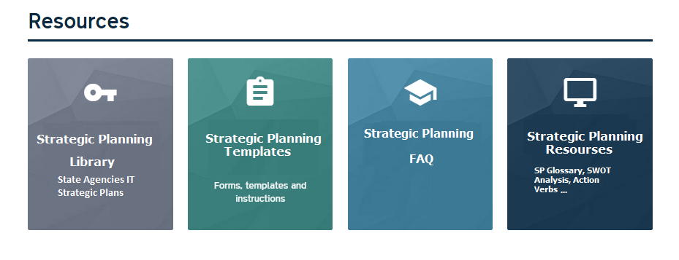

**Contact Us** Contact the team directly at [its.strategicplanning@nc.gov](mailto:its.strategicplanning@nc.gov).

Strategic Planning Resources:

* [2015-2017 NC Statewide IT Plan](https://ncit.s3.amazonaws.com/s3fs-public/documents/files/State-IT-Plan-2015-17.pdf)
* [2014 NC IT Restructuring Plan](http://it.nc.gov/document/statewide-it-restructuring-plan)
* Agencies IT Strategic Plans
* FAQ Strategic Planning
* Strategic Planning Glossary
* Strategic Plan Template
* List of Action/Strategic Verbs
* SWOT Analysis